THE VILLAGE OF

SAZOVICE
( project work )

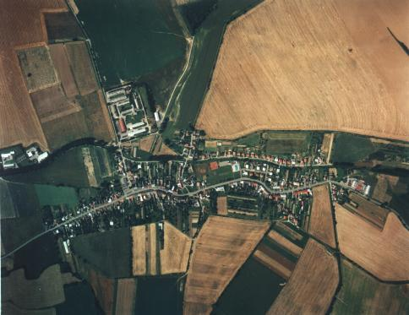

Written by VLADIMÍRA MIKLOVÁ
4. A
31. 10. 2002

Content

- Introduction
- How does the village of Sazovice arise?
- Symbols of the village
- A brief history
- Agriculture
- Education
- The fire brigade
- „DFS Konopka“
- St. Václav – the patron saint of the village
- Famous people
- The Interests
- Conclusion

Introduction

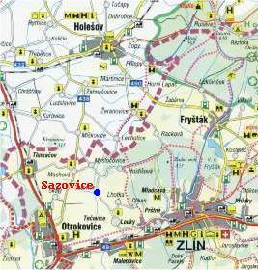

The village of Sazovice is situated in the lowland between Zlin and Otrokovice. It lies on the bank of the “Racková” brook (also called the “Svodnice”).
This brook pours itself into the Dřevnice river. The village has an area 392ha (332ha - arable land; 1,8ha – forest) and 683 inhabitants (31. 08. 2002).

The village of Sazovice on the map

It is also a village, where I have been living for more than 14 years. So I have decided to introduce it to the world.

How does the village of Sazovice arise?

The chronicler Vojtěch Velísek has written, that the village grow up from two old cottages. Both cottages were owned by fishermen from the old clan Šestákovi and they were situated near by the two ponds (on the place known as “Zahrázovo”).
The village of Sazovice is one of the oldest one in the Zlin´s region. The first written notice about Sazovice is from the year 1362. And it is written there about a squire Wznatky in Sazowitz and his property, but the village did not belong to him. The owners were the Šternberks.
The name Sazovice was made by adding a suffix –ovice to the name Saza. Saza probably marks a colour of hair. So in the village of Sazovice people mainly with dark or black hair lived.
Archeological finding of burying-grounds, objects, arms,… from the stone age (1.500 BC) on areas “Lazy, Hony, Díly; from the iron-age and Slavonic age reflect about a rich history.

Symbols of the village of Sazovice

This year (2002) the village of Sazovice is holding its 640th year. Thanks to the decision of Václav Klaus ( the chairman of the Chamber of Deputies) the village has its own symbols: a device and a flag.


The device:
On the blue and silver escutcheon there is a golden star in the right top corner. In the top left corner there is a golden earth-board, at the bottom there is a red eagle´s pinion.


The flag:

On the red flag there is a blue cross with a white facing. In the middle of the cross a golden star is situated.

The village has also a round signet from 1694. It was made from brass. “Diedina Sazowicz” is written there.

a brief history

From the old time the inhabitants were agriculturists and stock breeders. They produced mainly cereals, beet, potatoes (- for support) and also hemp and flax (- for clothes and bed-clothes). People kiln-dried fruit: apples, pears, plums. From plumps they also cooked plum-jam.
In 1715 166 inhabitants lived in the village, since 1771 in houses with numbers – Marie Terezie`s reform. But the number of houses and also of inhabitants was very variable. There were lot of conflagrations (1840, 1871, 1873). Therefore local voluntary fire brigade was established in 1903.
Not only conflagrations, but also wars pothered inhabitants. Soldiery of Russia, France, Turkey and Sweden went through the village. It was connected with burglaries, sack and forces. Moreover catastrophic floods (1901, 1905,1911) and epidemic of black death (1840) and cholera (1866) almost destroyed this village.
The first World War was hard for the people too. 120 men were called up, 13 of them never came back home. Brothers Šestákovi fighted in the USA as pilots.
The time after the war was the period of prosperity. In 1929 some changes took place – electrification and establishment of telephone, 1936 sewer system and a new road.
The second World War was not so hard as the previous as for casualties. But people had a lack of food, agricultural rates were extremely high. In 1943 a couple of Russian parachutists landed in the area of Sazovice. A group of guerillas was also established there. The village of Sazovice was liberated by Rumanian army. 64 Rumanian were killed in that fight. The number of dead German soldiers is unknown. War damages were huge: 10 houses, the school and the bell tower were completely destroyed.
In the beginning of the 20th century more than eighty people moved to Zlin or Otrokovice, where Baťa established his factories.
In 1948 in the village of Sazovice were: two hammer-smiths, a tailor, a sewer, a backer, shoe-maker, plumber, cooper, two butchers. In the village there were two pubs (in one of them there was also a small cinema) and one general store. There was also a brick-kiln (closed in 1912). Bus service was handled by Stanislav Vlček up to year 1950.
During the period of reign of communists about 100 houses were built or renewed in the village.
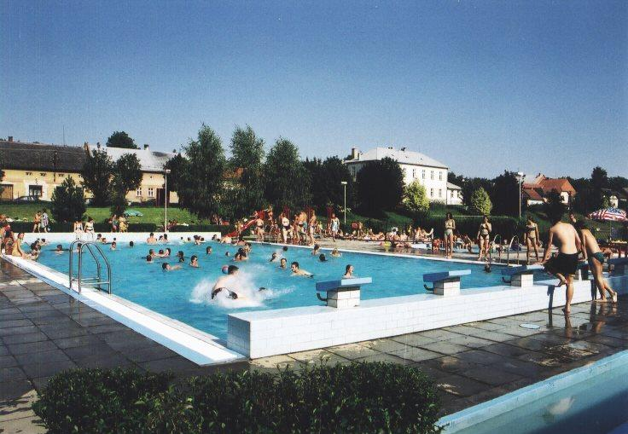

In 1986-89 a new sports-centre was built in the village of Sazovice. It includes a swimming-pool, a sauna, two tennis courts, a table-tennis, a football and handball court and also a pub.

Gas-fired central heating was put all over the village in 1991.
The most important capital construction after the “Velvet revolution” was carried out in 1999. There was built a new building, where a new local council, club-rooms for firemen and youth, rooms for surgery and hairdresser´s and a very nice ball room is situated.
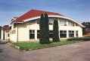

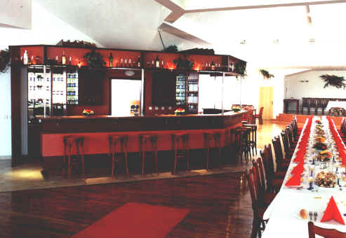

After the year 1989 have many people started to carry business.
agriculture

In the beginning the village of Sazovice had an agricultural character. In 1960 more than a half of people were still dependent on agriculture.
In 1948 the power was taken over by communists in the Czech Republic and the period of planning agriculture came. The “JZD” (“agricultural institution”) was established in 1952. But after one year it came to pieces and new one was established in 1956. In 1990 (after the “Velvet revolution”) it was renamed. Now it is known as ZD Zlín.

Education

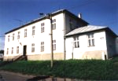

School in the village of Sazovice

An elementary school was established in 1873, but unfortunately after 114 years it was closed and children started to attend the elementary school in the village of Mysločovice. During this time the building was used as the local council and two rooms served as the library. In 1952 a kindergarten was established there.
The education was recovered in the school-year 1994-1995 by Mgr. Marie Kolářová, who is a director of both the kindergarten and the elementary school (even as only with five classes). The building is newly reconstructed, the equipment is modern. The school also take part in the project “INDOŠ” = the Internet to schools.
The kindergarten has 22 and the elementary school 29 children this school year. There are 7 employees at the school.

The Fire brigade

The Fire brigade of the village of Sazovice was established after the serie of fires (in 1900, 1901, and 1902) in 1903. It had 32 members and also equipment – a fire engine and a garage for it. Now the village of Sazovice has 106 voluntary firemen: 28 children and 78 adults – 70 men, 8 women. They also own a club-room.
They take part in lot of competitions and belong to the best in the Zlín´s region this year. Moreover they organize many cultural actions: “The leading of the bear”, “New Years´s Eve party”, “St. Valentin´s party”, celebrations of St. Václav, fire-competitions of course, and “The Old Hanácké Law” every ten years.

“dfs konopka”

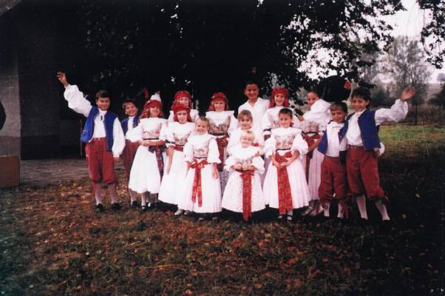

“DFS Konopka” (children folklore organization) was established in the occasion of a celebration “The Old Hanácké Law” in the village of Sazovice in 1996.
Activity of this organization is focused on traditional dance, songs and customs from the region called Haná. Each member has own traditional costume. They take part on several folklore parades (for example in Vlčnov or Schonbrunn - Austria).
They also have a programme called “The Vivid Bethlehem”. It means they play a theatreplay about the birth of Christ. It is a traditional performance each Christmas, which is played under the sky.

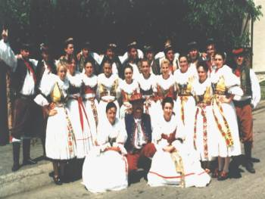

Religion

The village of Sazovice belonged to the parish of Mysločovice. The first written mention about this fact is from the 14th century.
In the 15th century utrakvism has leaked to this region.
After this period people started to believe in evangelic belief. The most important Reverend was Jakub Delfín by that time, who lived in the village of Mysločovice.
Catholic belief was renewed in the village in the 17th century. But the church in Mysločovice was very old and in a bad condition. That is why count of Rottal decided to built a new church on this site.
The Baroque building was completed in 1758. It is the work of the architect Tomáš Šturma. The church was dedicated by Jindřich Kraus, who was the dean of the parish of Holešov. Contemporary bells are not original. The original bells were destroyed during the first World War. In front of the church there is also a Baroque chapel of St. Jan Nepomucký.
The village of Sazovice is a village without a church – there is only a bell-tower, which was built in 1947.

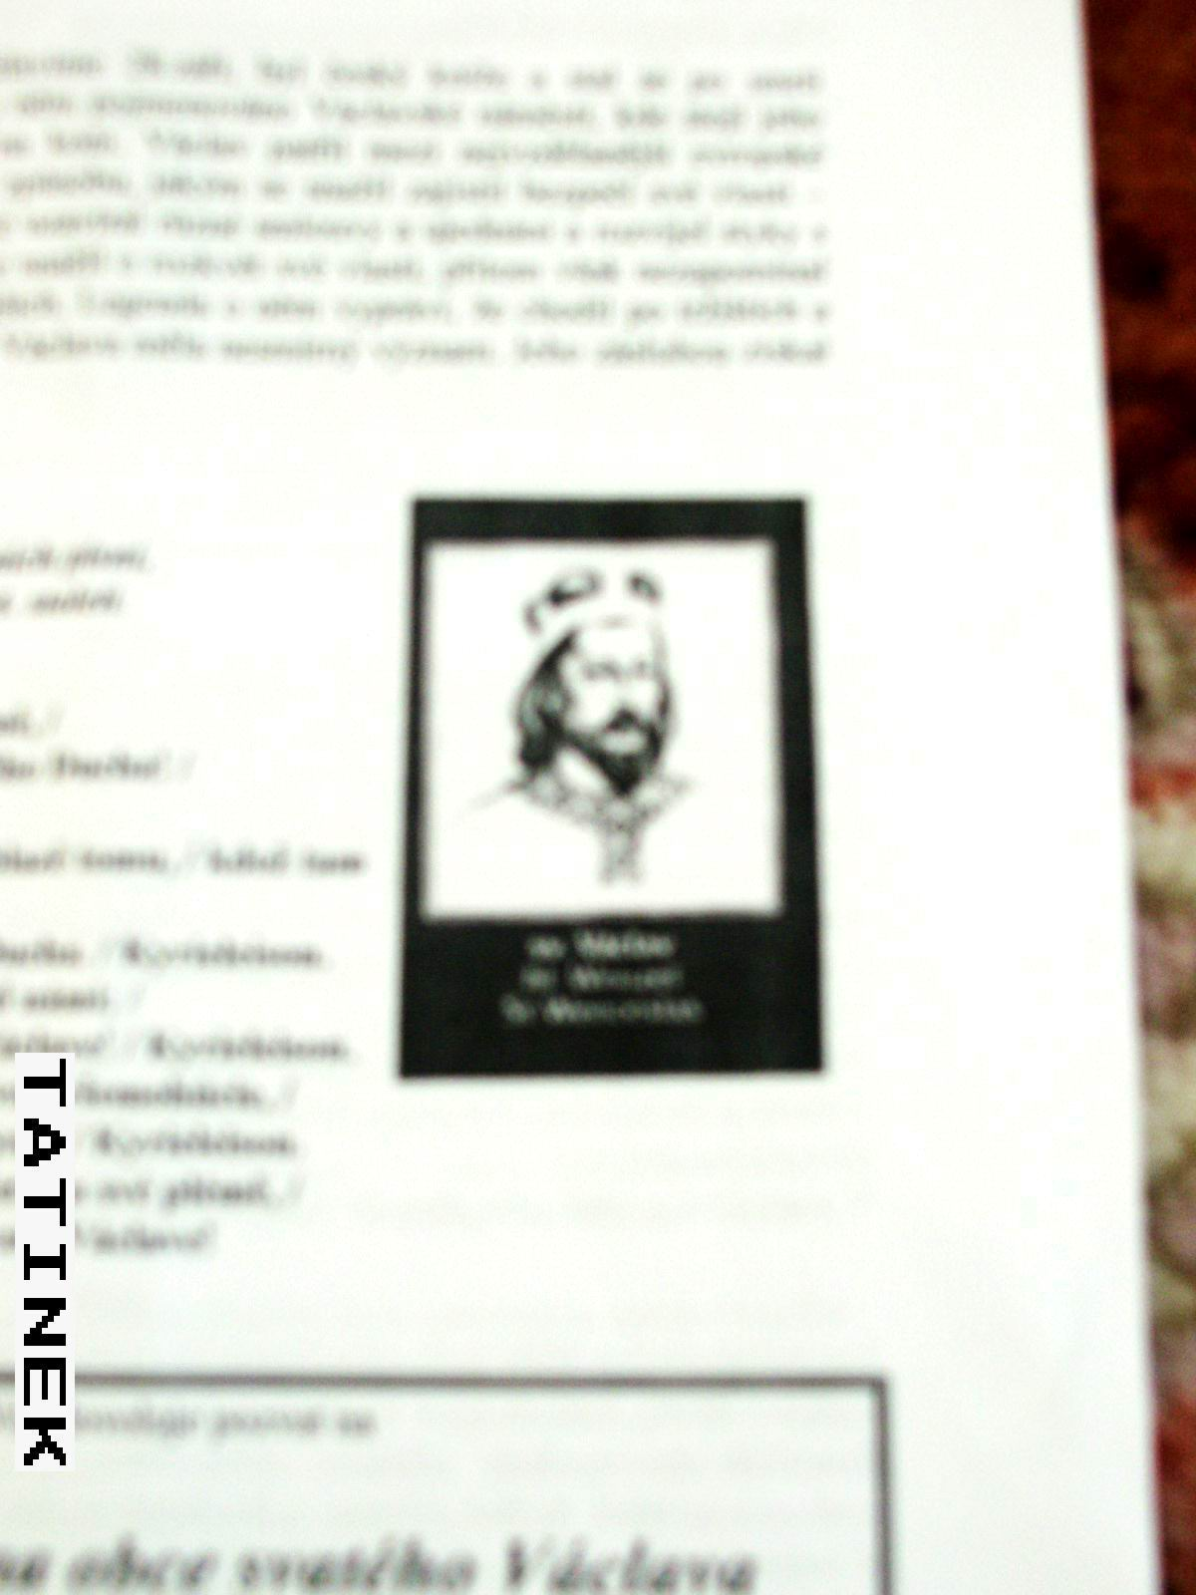

Saint Václav, whose name-day is celebrated on September 28, was the Czech prince. After his death he became the patron saint of our country. Also in Prague there is a “Václavské square” with a statue of his as a knight on the horse.
He was very well educated and endeavour to do peace politics. The story goes that he did not forget the poor, he went trough the markets and bought slaves. After that he gave them freedom.

Saint Václav,

the patron SAINT of the village

FAMOUS PEOPLE

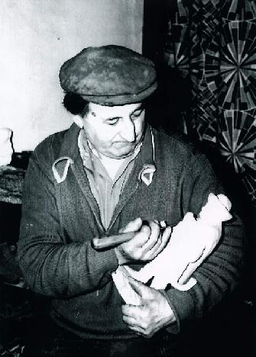
- Bernard Kučera (1922-1999)

In 1969 received he the diploma „the folk wood-carver“. He is famous for his beautiful creches which is possible to see in the church at Mysločovice and some of them owns The Museum of South Moravia. And his wooden sculptures were part of long-term exhibition on the castle in Malenovice.
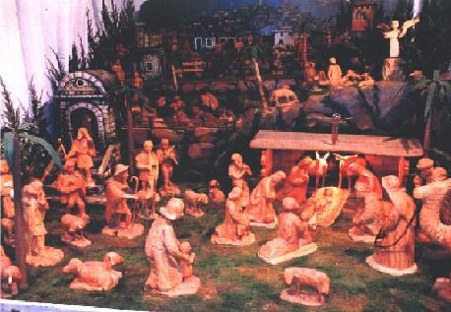

- František Šesták (*1935)

Academic painter and illustrator is living in Bratislava now. He painted the icon „Cyril and Metoděj“ for the church at Mysločovice and he has participated on the restoration work there.

- MUDr. Antonín Slováček (1910-1994)

He was born in the village of Sazovice at the house number 31. He has studied the medical University in Brno. In 1978 he received the „Zlatá plaketa dr. Jánského“. Felix Slováček – a famous musician – is his son.

THE INTERESTS

Worthy of remark curiosity was a falling-stone, which weighted 411,98g. It felt down in the area of “Záhumenice” on 28 June, 1934. The falling-stone was found by František Veselý and A. Kulendová . It was stored in the collection of Moravské Museum in Brno.

An ice-whirlwind was in the village of Sazovice during the summer 1969. The damage on corps was 100%.

The traditional drumbeat of important messages ended in 1947. The last drummers were Josef Kulenda and František Velísek. They were replaced by a local rediffusion in 1948.

Bohumil Zahradník-Brodský – the very famous writer by that time – married miss Růžena Nováková from the village of Sazovice in 1937. The curiosity is, that he was 75 years old, but she was only 25.

On 25 January, 1938 the inhabitants of the village saw an uncommon phenomenon – the aurora.

conclusion

The village of Sazovice has it´s own local council. That is a very good thing, because people, who live there, decide about the village. So the members of the local council can help people more effective by while they understand their problems.

In my opinion, the biggest problem is the local bus transport. The busses do not go as often as the inhabitants wish. Mainly at weekends, when four busses go to or from Zlín. What is more, the last bus to Zlín goes at 4 p.m. and the last bus from Zlín at 6:30 p.m. So if somebody does not have a car, it is impossible for him/her to go to the cinema or theatre at the weekend.

On the other hand there are lot of people in the village, who try to keep traditions. So in the village of Sazovice it is still possible to see old traditions like “Masopust”, “Májka”, “Burning of Witches”, throwing “Morena” away – which symbolizes the end of Winter.

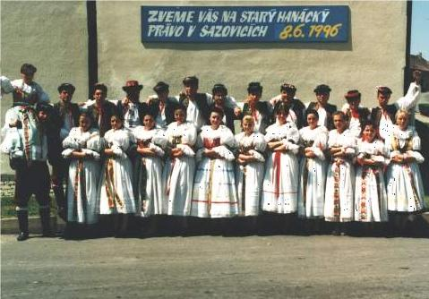

“Old Hanácké Law”

– the most impressive tradition. The servants take over the power above the village on one day. It is connected with great celebrations in traditional costumes and it is held every ten years.

From the list of celebrations - which is not complete - it is evident, that culture has a great support.

Because there are lot of people, who believe in God, there are plans to built a new chapel. But this and many other things depend on the results of the elections to the local council, which are held this year.

Sources

The Internet: www.volný.cz/obec_sazovice
Sazovice – the collective of authors, 2002
Marie Jarošová - the mayor of the village of Sazovice
Zlínsko – the collective of authors, 1999

